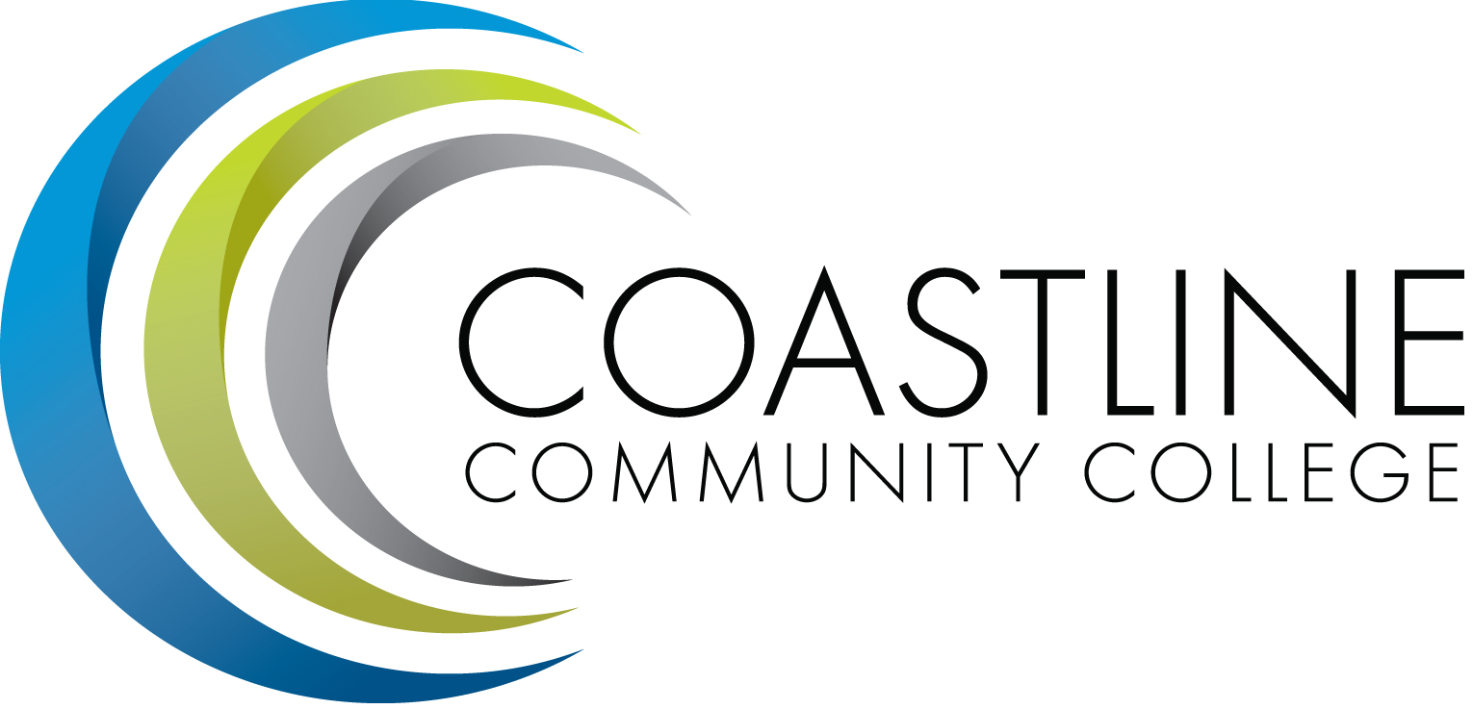
Planning, Institutional Effectiveness, and Accreditation Committee (PIEAC)
February 15, 2017
1:30 p.m. to 3:30 p.m.
Fourth Floor Conference Room

- CALL TO ORDER
  - Roll Call
  - Welcome
  - Adoption of Agenda
  - Defer Minutes: December 7, 2016

- REPORTS
2.1 CCCD Strategic Plan Review A. Zentner
2.2 Prioritization Next Steps A. Zentner
2.3 P1 FTES Estimates A. Zentner

- DISCUSSION
3.1 2016-17 ISLOs Survey A. Zentner
3.2 2017 SAO Surveys A. Zentner
3.3 Van Service J. Blanco
3.4 Mission Statement Review Results and Activity A. Zentner and D. Pittaway

4. STANDING REPORTS
4.1 Accreditation V. Rodriguez
4.2 Budget Committee R. Lockwood
4.3 Program Review A. Zentner
4.4 Grants D. Aistrich
4.5 President’s Report L. Adrian
4.6 Wing Reports V. Rodriguez, C. Nguyen, R. Miyashiro
4.7 College Council V. Rodriguez
4.8 Facilities C. Nguyen
4.9 MECTBD J. Groot
4.10 Student Success Committee B. Keeler
4.11 Institutional Effectiveness Grant A. Zentner
4.12 College Promise L. Adrian
4.13 Other Committees Committee

4. ANNOUNCEMENTS (1-2 minutes per)

5. ADJOURNMENT

